Curriculum Vitae

Christiaan Johannes Hattingh

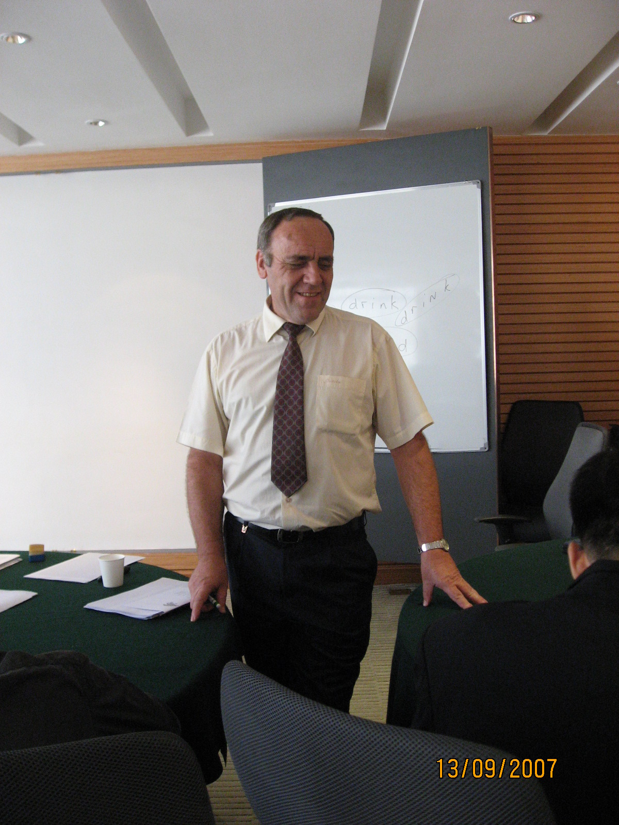

PERSONAL DETAILS

Surname: Hattingh
Names: Christiaan Johannes
Chinese name: 天福海
Race: Caucasian (European)

Date of birth: 1951 November 08
Nationality: South African
ID number: 511108 5031 086
Passport number: 464508346
Gender: Male
Marital status: Divorced in 1994
Children: Daughter (31), Son (27)
Criminal record: None
Health: Excellent (Never been hospitalized due to illness.)
Computer literacy MS Word, MS Excel, Internet Explorer
IELTS Tutor: The Head IELTS Examiner, ShenYang.

ACADEMIC QUALIFICATIONS

B.A. Degree: University of South Africa (1987)
Majors: Child Psychology & Philosophy
(Original document available on request)

Polytechnic Diploma: Forest Management (1974)
Passed with distinction
(Original document available on request)

TEFL / TESOL: 40 Hour Intensive Course (2007)
i-to-I teachenglishabroad.

- 2 -

ESL EXPERIENCE IN CHINA

Shenzhen
Aug 2007 – Present: Mission Hills Golf Resort
Placements: 1. English Language Coordinator
(Managing the English training of 8000 employees.)
(Teaching Business and Hospitality English.)

Wuxi
Sep 2006 – Jul 2007: ABC Language Center
Placements: 1. Teacher: IELTS, Business Management

Shenzhen
Sep 2005 – Aug 2006: Mission Hills Golf Resort
Placements: 1. English Language Coordinator
(Managing the English training of 5000 employees.)
(Teaching Business and Hospitality English.)

Zhongshan
Dec 2004 – Aug 2005: Skyline Language School
Placements: 1. Business English: Shangri-La Hotel, Ming Yang Co.
2. IELTS Instructor

Shenyang
Oct 2002 – Aug 2003: JiaHua IELTS Training Center
Placements: 1. IELTS instructor for EAP students
2. Oral speaking for Chinese teachers

Sept 2003 – May 2004: Shutong Teacher Placement Center
Placements: 1. Global IELTS Training Center
2. Hu Shi Tai Economic College
(Lecturer in American & British culture as part of the MBA
preparation program)

June – November 2004: BoYa Foreign Language Training Center
Placements: 1. Head: English Department
2. Business English classes for a wide range of companies.

LANGUAGES

English: Fully proficient
Afrikaans: Fully proficient
Zulu: Partly proficient
Mandarin Survival level

- 3 -

WRITING ACHIEVEMENTS

1. IELTS Writing
Published in February 2003 for JiaHua IELTS Centre.
Covers 54 topics in Part 2.

2. IELTS Speaking
Published in March 2003 for JiaHua IELTS Centre.
Covers all three parts, with 55 topics in Part 2.

3. Oral English
A Workbook for Students for BoYa Foreign Language Center.

4. How to learn English.
Guidelines for EAP students including the “Input” method,
Motivation, Examination techniques, etc.

REFERENCES

On request

CONTACT NUMBERS

Mobile: 137137 64676

Website: www.tianhattingh.com

Please use a proxy like www.freeproxyserver.ca if needed.

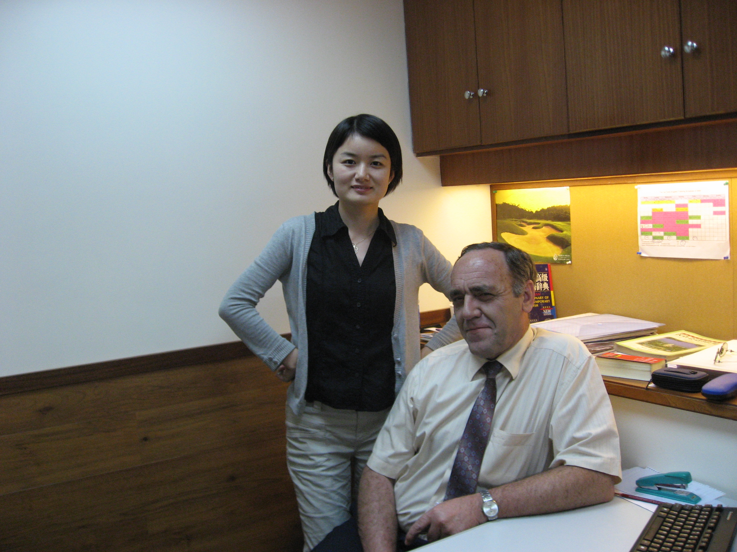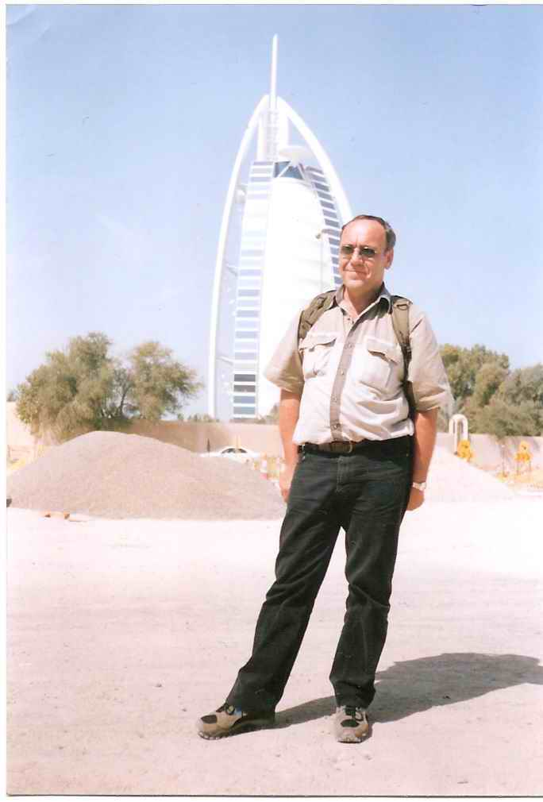

Work & play

